***1.Password Protected Lock System***

1. **Block Diagram**

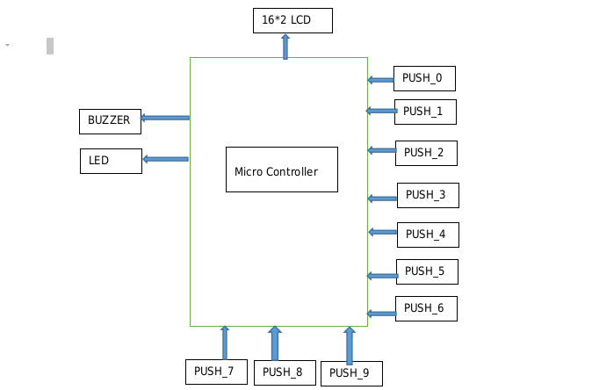

1. **FlowChart**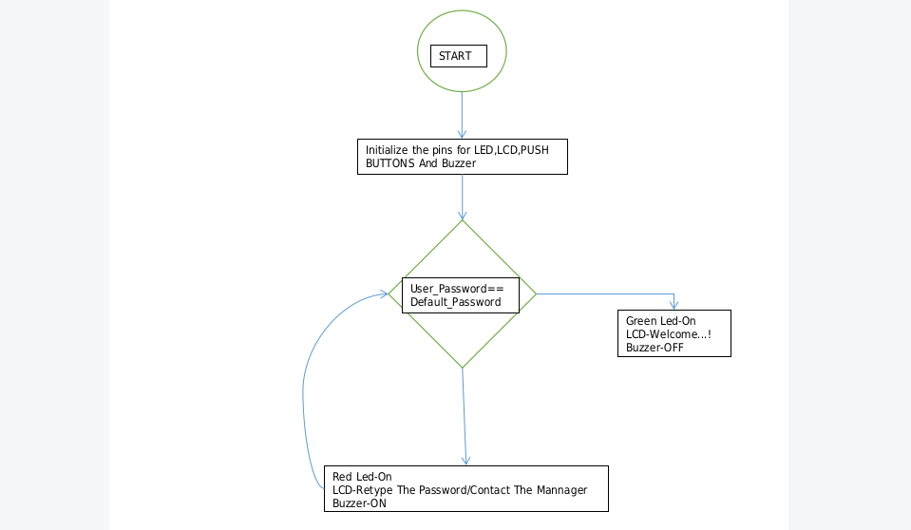
2. **Table**

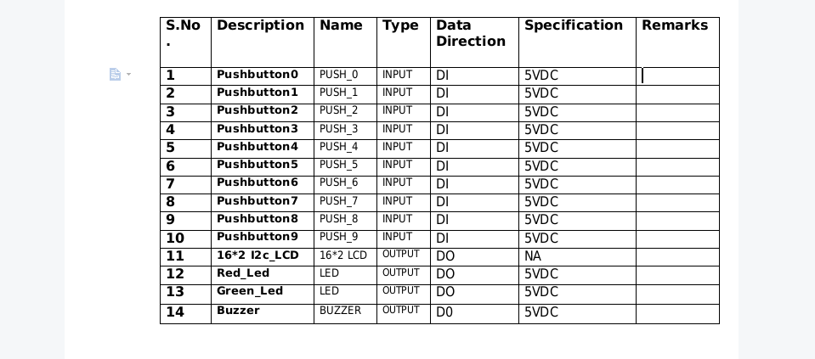

1. **C Code**

#include <LiquidCrystal.h>

#include<string.h>

const int rs = A5, en = A4, d4 = A3, d5 = A2, d6 = A1, d7 = A0;

LiquidCrystal lcd(rs, en, d4, d5, d6, d7);

unsigned int arduino_button_pins[]={0,1,2,3,4,5,6,7,8,9};

unsigned int button_present_values[]={0,0,0,0,0,0,0,0,0,0};

unsigned int button_past_values[]={0,0,0,0,0,0,0,0,0,0};

const int Green_LED=10;

const int Red_LED=11;

const int Buzzer=12;

int key_pressed()

{

for(uint8_t button=0;button<10;button++)

{

int present_state = digitalRead(arduino_button_pins[button]);

int previous_state= button_past_values[button];

if(present_state)

{

if(present_state != previous_state)

{

button_past_values[button] = present_state;

char str[10];

sprintf(str,"KEY:%d",button);//Mearge the Strings

lcd.setCursor(0,1);

lcd.write(str);

return button;

}

}

else

{

button_past_values[button] = 0;

}

delay(50);

}

}

int press_button()

{

if(digitalRead(0)||digitalRead(1)||digitalRead(2)||digitalRead(3)||digitalRead(4)||digitalRead(5)

||digitalRead(6)||digitalRead(7)||digitalRead(8)||digitalRead(9))

{ return 1; }

else

{ return 0; }

}

void setup()

{

for(int i=0; i<10;i++)

{

pinMode(i,INPUT);

}

pinMode(Green_LED,OUTPUT);

pinMode(Red_LED,OUTPUT);

pinMode(Buzzer,OUTPUT);

lcd.begin(16, 2);

lcd.write("ENTER PIN");

}

const int Preset_Pin=2332; //Password prefixed saved

int pinByUser[] ={0,0,0,0} ;

int keySequence = 0;

int Final_Pin = 0 ;

void loop()

{

while(press_button())

{

if(keySequence<4){

pinByUser[keySequence]=key_pressed();

lcd.setCursor(6,1);

char pin[4];

sprintf(pin,"DIGIT%d-%d",keySequence+1,pinByUser[keySequence]);

lcd.write(pin);

}

else if(keySequence==4){

lcd.setCursor(6,1);

for(int a=0; a<4; a++)

{

Final_Pin = (Final_Pin * 10) + pinByUser[a];

}

char pin[4];

sprintf(pin,"PIN:%d",Final_Pin);

lcd.write(pin);

delay(50);

if(Final_Pin == Preset_Pin){

lcd.setCursor(6,1);

lcd.write("Welcome");

lcd.setCursor(0,0);

lcd.write("ACCESS AUTHORIZED !!");

digitalWrite(Green_LED,HIGH);

}else{

lcd.setCursor(6,1);

lcd.write("-!FAILED!-");

digitalWrite(Red_LED,HIGH);

}

}

else{

lcd.setCursor(0,0);

lcd.write("MAX LIMIT REACHED");

}

delay(1200);

keySequence++;

}

}

1. **Simulation Circuit**